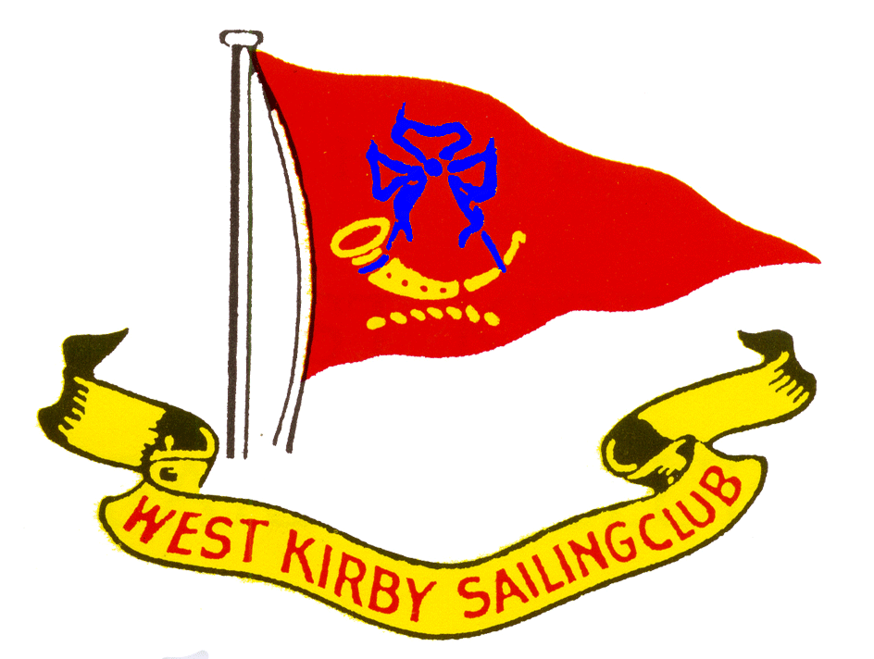West Kirby Sailing Club
REGATTA
Sunday 15th July 2018
NOTICE OF RACE

President: | Mr P.Y. Price
Commodore: | Mr J. Burthem
Vice Commodore: | Mr J-L Simons
Rear Commodore: | Mrs H. Brown
Hon. Secretary: | Mrs W. Jones
Hon. Treasurer: | Mr N. Ledingham
Captain: | Mr M. Mayhew
Hon. Sailing Secretary: | Mr M. Whittingham Jones
Official Handicapper | Mr A. Marston

HW 13.22, 9.32 Metres

Race No | Classes | Code Flag | Start Time
1 | Liverpool Bay Falcon | R | 11.35
2 | Limbo 6.6 | Num 6 | 11.38
3 | Hilbre Island One Design | I | 11.41
4 | West Kirby Star / Hoylake Opera / Seabird Half Rater | E | 11.44
5 | Handicap Catamarans (including Dart 16) | F | 11.47
6 | Dart 18 Catamarans | D | 11.50
7 | Cruisers | H | 11.53
8 | Fast Handicap Dinghies (PY<1000) | T | 12.00
9 | Medium Handicap Dinghies (PY 1000 – 1165) - including Aeros | W | 12.03
10 | Slow Handicap Dinghies (PY > 1165) | V | 12.06

All Classes except Cruisers will have two races sailed back to back. Races 1 - 7 will start from the tidal start boat, Races 8 – 10 will start from the dinghy start boat. All Classes except Race 7 will sail an Olympic Course.
Entrance Fee: Entries will be taken in the WKSC clubhouse on Friday 13th July, between 1800 and 2000. Also on Sunday 15th July from 0900 in the clubhouse. Refreshments will be available after racing in the WKSC Summer Pavilion.

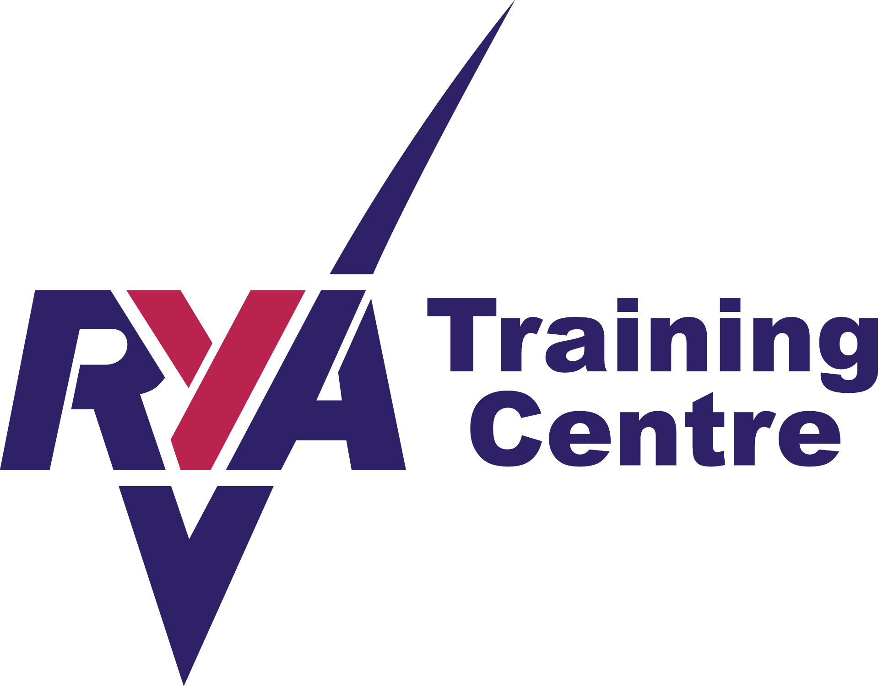Note: Adjusted PNs will be used for the following Classes sailing in Races 8 and 9: Albacores 1045; Finns 1045; International Canoe ODs 910; International Canoe Slurp ODs 910. Other classes will use the RYA 2018 PNs.

Friday 13th July: Illusion Regatta, starting at 15.00 on the Marine Lake - 5 races
Regatta Briefing for Dinghies in WKSC at 17.30
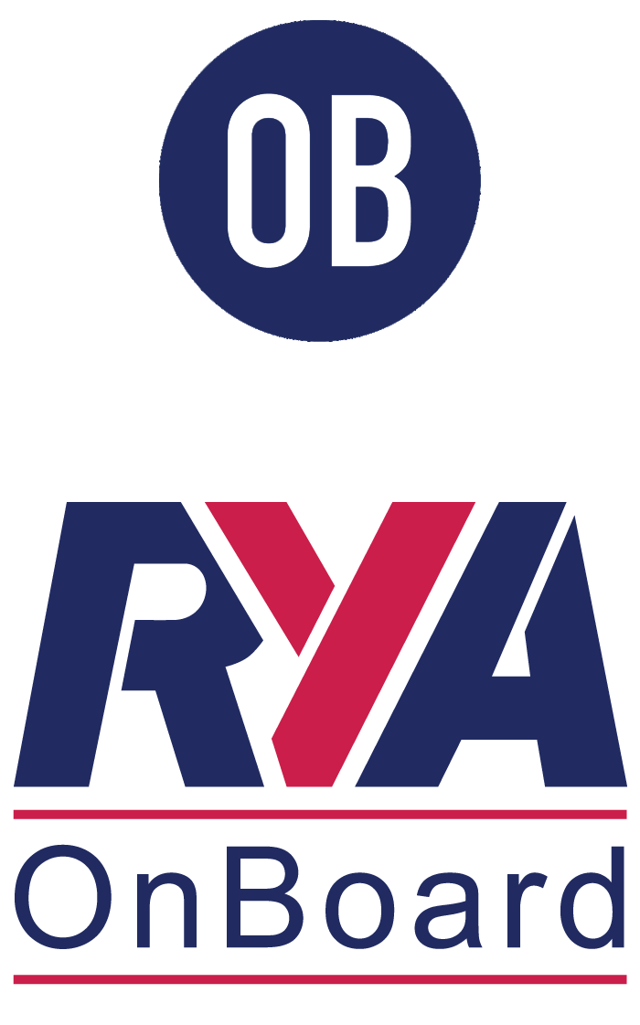 “Sailing For Fun” on the Marine Lake from 18.00
BBQ from 18.30 and 70’s Disco from 21.30

Visitors are very welcome – for further information please contact West Kirby Sailing Club
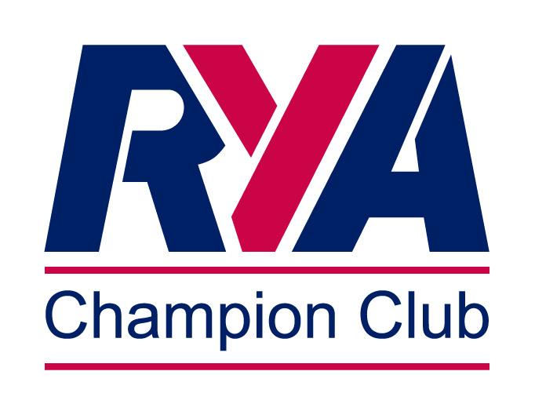Tel: 0151 625 5579
Website www.wksc.org.uk email office@wksc.org.uk

